Award-winning HOLZ-HER Innovations

Since the company was taken over by Weinig AG in 2010, a great deal has happened at the Woodworking Specialist HOLZ-HER. Numerous projects started at the very beginning with clearly defined customer benefit, including a variety of synergistic effects, have now become standard features on the market.

Here our policy of anticipating trends is demonstrated by the numerous awards HOLZ-HER has received for its innovations in the recent past.

At the IWF Exhibition held recently in Atlanta, HOLZ-HER received two of the highly prestigious Challenger Awards proving its technical lead. One award was for the new EVOLUTION 4mat vertical CNC machining center offering the unique capability of formatting all four sides in one clamping operation. The other was for the newly developed GluJet glue application system which was praised by the jury for its "ultimate level of flexibility, quality and value". Whereby the jury emphasized the clear and superior customer advantages of our GluJet.

In 2012 the GluJet application system already received the Gold Star Award as the best system for processing PUR glues at the AWISA Fair in Australia. HOLZ-HER was again successful in receiving an award at the AWISA in 2014. This time the new HOLZ-HER Ltronic received the Gold Star Award as the most cost-efficient system for activating laser edging.

These numerous awards clearly show that HOLZ-HER has remained on its course to technological leadership.

Attachment:
Fig.: HOLZ-HER and WEINIG proudly present the two Challenger Awards received at the IWF Exhibition in Atlanta

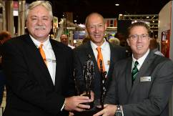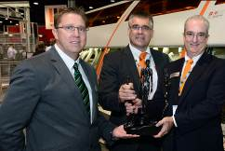
Left to right: Left to right:
Michael Cassel, Stefan Benkart, Dan Murphy Dan Murphy, Frank Epple, Rick Hanigain

Fig.: The Challenger Award 2014
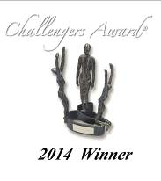
For further information please contact:

HOLZ-HER GmbH
Plochinger Straße 65
D-72622 Nürtingen
Tel.: +49 7022 702-129
Fax: +49 7022 702 101
E-mail: Philipp.Schulte-Derne@holzher.com
Website: www.holzher.com

